Planning Department
Stafford Borough Council
Civic Centre

Riverside
Stafford
ST16 3AQ
Re: Objection to Planning Application for Site North of Shaws Lane, Eccleshall
Planning reference: 25/41542/OUT
Dear Case Officer
I am writing to object to the planning application above in Eccleshall. My objection is based on clear conflicts with the Eccleshall Neighbourhood Plan, the Stafford Borough Council Local Plan, and relevant provisions of the National Planning Policy Framework (NPPF), as well as the potential harm to the Eccleshall Conservation Area.
Personal Comments

- The following planning applications were not supported by the SBC planning department:

- 25/41599/PAGR - Prior Approval - Construction of an agricultural storage building, Land At The Hollies, Pershall. Refused; By reason of its substantial scale, isolated roadside location and consequent visual prominence within an otherwise open field, the proposed agricultural building would unacceptably harm the visual amenities of the area. The proposal is therefore contrary Policies E2 (d) and N1 (g) and (h) of The Plan for Stafford Borough.
26/41793/PIP this application was not supported by SBC Planning and Placemaking due to conflicts with NPPF paragraphs 11,110 and 115, together with Spatial Principal 7
- I support these decisions by SBC. However, these decisions set a precedent, if two dwellings on Doley Road, Eccleshall conflict with NPPF guidance and Local Plan principals and a simple agricultural building harms the visual amenities of the area proposed, then the building of 150 houses on open and productive farmland must do the same and therefore application 25/41542/OUT/OUT must be rejected on the following grounds:
By reason of its substantial scale, location encompassing the conservation area and consequent visual prominence within an otherwise open field, the proposed housing estate would unacceptably harm the visual amenities of the area. The proposal is therefore contrary Policies E2 (d) and N1 (g) and (h) of The Plan for Stafford Borough.

Conflict with the Eccleshall Neighbourhood Plan

  - The proposal for this application is inconsistent with Neighbourhood Plan Policy 5, which requires new development to:
- Respect the historic character of Eccleshall;
- Preserve or enhance the setting of the Eccleshall Conservation Area;
- Maintain the town’s distinctive character and local architecture.
- The northern half of this proposed development would lie inside the Conservation Area and compromise key views into and out of the Area and alter the historic landscape setting that the Neighbourhood Plan seeks to protect.

Conflict with the SBC Local Plan (Part 1 & Part 2)
- Settlement Hierarchy and Boundaries

The Neighbourhood Plan directs growth to areas that support sustainability, avoid overextension of the settlement, and protect sensitive historic land. Policy 1 specifically restricts development outside defined settlement boundaries unless exceptional circumstances apply. This site lies outside the settlement boundary and therefore conflicts with this spatial strategy

Local Plan Policy (Spatial Principle SP6 and SP7) restricts development outside these limits unless it is justified by being essential. This development conflicts with SP7 b), f), g), h), k). This site lies beyond the established settlement boundary, and no such justification has been provided

- Under the Plan for Stafford Borough (2014) and Part 2 (2017), Eccleshall is designated as one of the Borough’s 11 Key Service Villages.
- Part 2 establishes definitive settlement boundaries for the KSV’s, including Eccleshall.
- This means that development falling outside them is contrary to the settlement strategy underpinning the Local Plan, unless very special justification exists. The proposal would be contrary to the adopted development limits for Eccleshall under the Local Plan.
- There is a brownfield site in the centre of Eccleshall that should be used before green field sites are considered.

Protection of Historic Environment and Landscape Setting
- The Plan for Stafford Borough recognises the historic environment — including Conservation Areas, listed buildings, historic landscape features, and views/setting — as a unique and irreplaceable resource
- Under Policy N9 Historic Environment, the Plan requires that proposals affecting heritage assets must include sufficient information to assess impact (e.g., heritage statements), and that settings and views of heritage assets be respected.
- The policy also emphasises conserving the wider landscape character — including hedgerows, field boundaries, trees, historic field patterns (ridge and farrow) — that contribute to local distinctiveness.

Impact on the Eccleshall Conservation Area
- The Local Plan’s Historic Environment policy (Policy N9) requires that development preserves or enhances heritage assets and their settings. The proposed scheme would:
- Encroach visually upon the Conservation Area.
- Affect identified heritage assets setting i.e Grade 2 listed housing on Kerry Lane, adjacent to the site, and historically significant houses on its Northern boundary.
- Alter the rural edge that forms part of the Conservation Area’s setting.
- Undermine the aims of the historic environment.

This represents a clear breach of SBC heritage policies.

Infrastructure and Sustainable Development
- Local Plan Policy I1 (Infrastructure Delivery Policy) requires that development must be supported by adequate infrastructure, including transport, drainage, and community facilities. The application fails to demonstrate sufficient local infrastructure capacity to support new development in this location. Ie Drainage, Schools, Medical, Roads, Access.
Conflict with the National Planning Policy Framework (NPPF 2023, especially Chapter 16 – Historic Environment)
- Heritage Protection (NPPF Section 16). Under NPPF paragraphs 199–202, great weight must be given to the conservation of heritage assets. Harm to a Conservation Area (a designated heritage asset) must be clearly justified, and where such harm is not outweighed by public benefits, permission should be refused. The harm caused to the Eccleshall Conservation Area’s setting and significance is neither addressed nor justified in the proposal.
- Under Paragraph 200, any application affecting a heritage asset must describe the significance of the asset and the contribution of its setting.
- Where a proposed development leads to substantial harm to (or total loss of) significance, Local Planning Authorities should refuse consent — unless very strong public benefits exist that clearly outweigh the harm.
- The NPPF also encourages opportunities for development within or affecting heritage assets (including Conservation Areas) only if the development preserves or enhances those elements of the setting that make a positive contribution to the asset.
In this case, there is no evidence that this application provides a robust heritage impact assessment or justification demonstrating that any harm to the setting of the Conservation Area is outweighed by substantial public benefits. As such, the application fails to meet national heritage protection requirements.
- Sustainable Development Principles (NPPF Section 2). The NPPF requires sustainable patterns of growth. Development should be located where it enhances sustainable travel, minimises environmental harm, and aligns with local plans. This site does not meet these principles.
- Open Countryside Protection

Under NPPF paragraphs 174 and 180, local planning authorities must protect valued landscapes and maintain the intrinsic character of the countryside. Development on this site would result in the loss of open countryside and harm local landscape character.

Site Sensitivity
- The Stafford Borough Council Landscape Sensitivity Study classified this area as High. The assessment clearly states that only 7 of 140 sites have been assed as High and ‘significant effects are predicted. Mitigation unlikely to be possible”

Tree Preservation Order
- The trees on this site are protected by a TPO and the hedges by national policy-Hedgerow Regulations 1997, Environment Act 1995. These hedgerows have been in existence for over 30 years and are therefore classified as important.

Impact on the community
- Crown Surgery
The Crown Surgery is a member of the NHS Stafford and Surrounds Clinical Commissioning Group and provides services to 7850 patients, soon to be increased by 1500 from outside their current area, reaching the recommended maximum. The CCG has no plans to expand facilities or increase numbers of GPs, even if they existed! Residents already have to travel to Stafford Hospital for simple ECG and blood tests. Increased patient numbers from this development will lengthen already long waiting times for appointments and result in increased car journeys to Stafford and Stoke.
- Traffic
Car journeys will increase, as there are few jobs in Eccleshall, north to the industrial Estates, east to Stafford, Stone, etc, west to Market Drayton.
- Shaws Lane and Kerry Lane are narrow country lanes. Shaws Lane crossroads with Horsley Road,Kerry Lane & Garmelow Lane with the Allotments at one end and the School and Community Centre at the other end. The lanes are 4m wide and have no verges or passing places. Shaws Lane has a 60mph speed limit and is used by HGVs (metal scrap yard further down Garmelow Lane), cars, farm vehicles and pedestrians.
- The Overton Manor estate feeds into the mini roundabout at the east end and a recent survey counted 167 cars outside 80 houses. The planned 150 houses plus the other planned site on the south side of Shaws Lane of 55 houses will add 430 cars using the Lane. This is unsustainable and the proposed widening will not help because the road then passes between the Community Centre and the School, which cannot be widened. Developer Surveys showing very light traffic down Shaws Lane are not taken during school opening and closing times, because then the road is jammed in all directions. They also discount the HGVs and farm vehicles that are regular users.
- Taylor Wimpey claim Eccleshall has ‘good connectivity’,The opposite is true! Bus timetables show the last bus from Stafford is 17.45pm (16.30pm on Saturdays) and15.25pm from Stone (with no Saturday buses). There is a 6.40am bus to Stafford, but the next one is 7.55am, arriving at 8.43am, because it goes via Woodseaves and Parkside! How do parents get their children to school or residents to and from work? They travel by car.
- Lack of Youth Facilities and Community Infrastructure
This proposal conflicts with Local Plan policies SP1, SP3 and C1.
Eccleshall already suffers from a significant lack of youth and recreational facilities. A Police Liaison Officer (18/11/25 report on 25/41120/OUT) warned that further housing growth without adequate facilities is likely to increase anti-social behaviour.
Research published in Landscape and Urban Planning and Environment and Behaviour demonstrates that:
Young people congregate in accessible open spaces where no alternative facilities exist.
Where such spaces lack supervision or structured use, incidents of vandalism, noise nuisance and low-level disorder increase.
Crime prevention guidance from Secured by Design also highlights that undefined or poorly overlooked open space can become a focal point for anti-social behaviour.
This development would increase the youth population without delivering appropriate community infrastructure, increasing the risk of social strain.
- Schools
Eccleshall has only one School, Bishops Lonsdale Academy for primary pupils and the availability of teachers is such that recently years have had to be combined so existing staff can cope. Secondary Schools are in Stone or Stafford, not all pupils can use the school bus service, and many parents drive their children to school, resulting in more road journeys, the opposite of Government Policy. In response to another very recent planning application Stafford Borough Council stated:
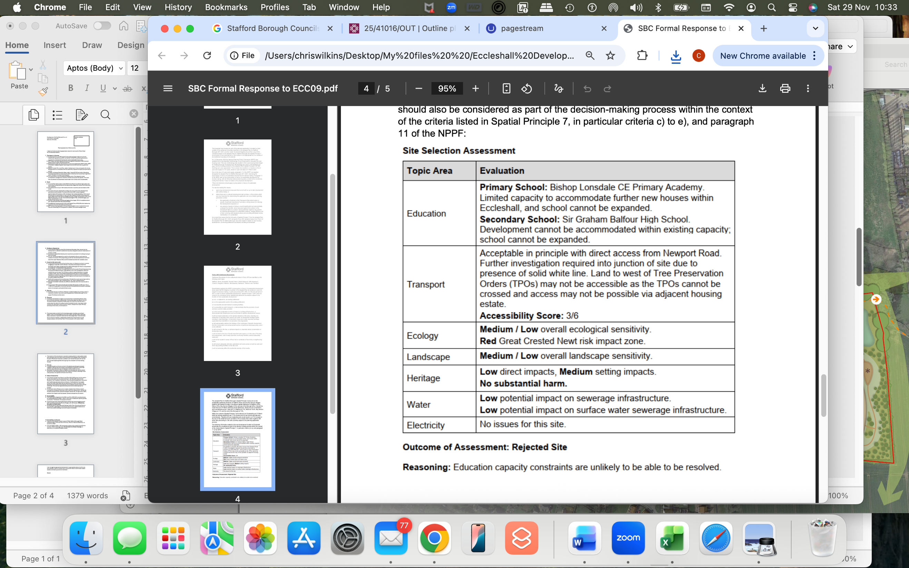
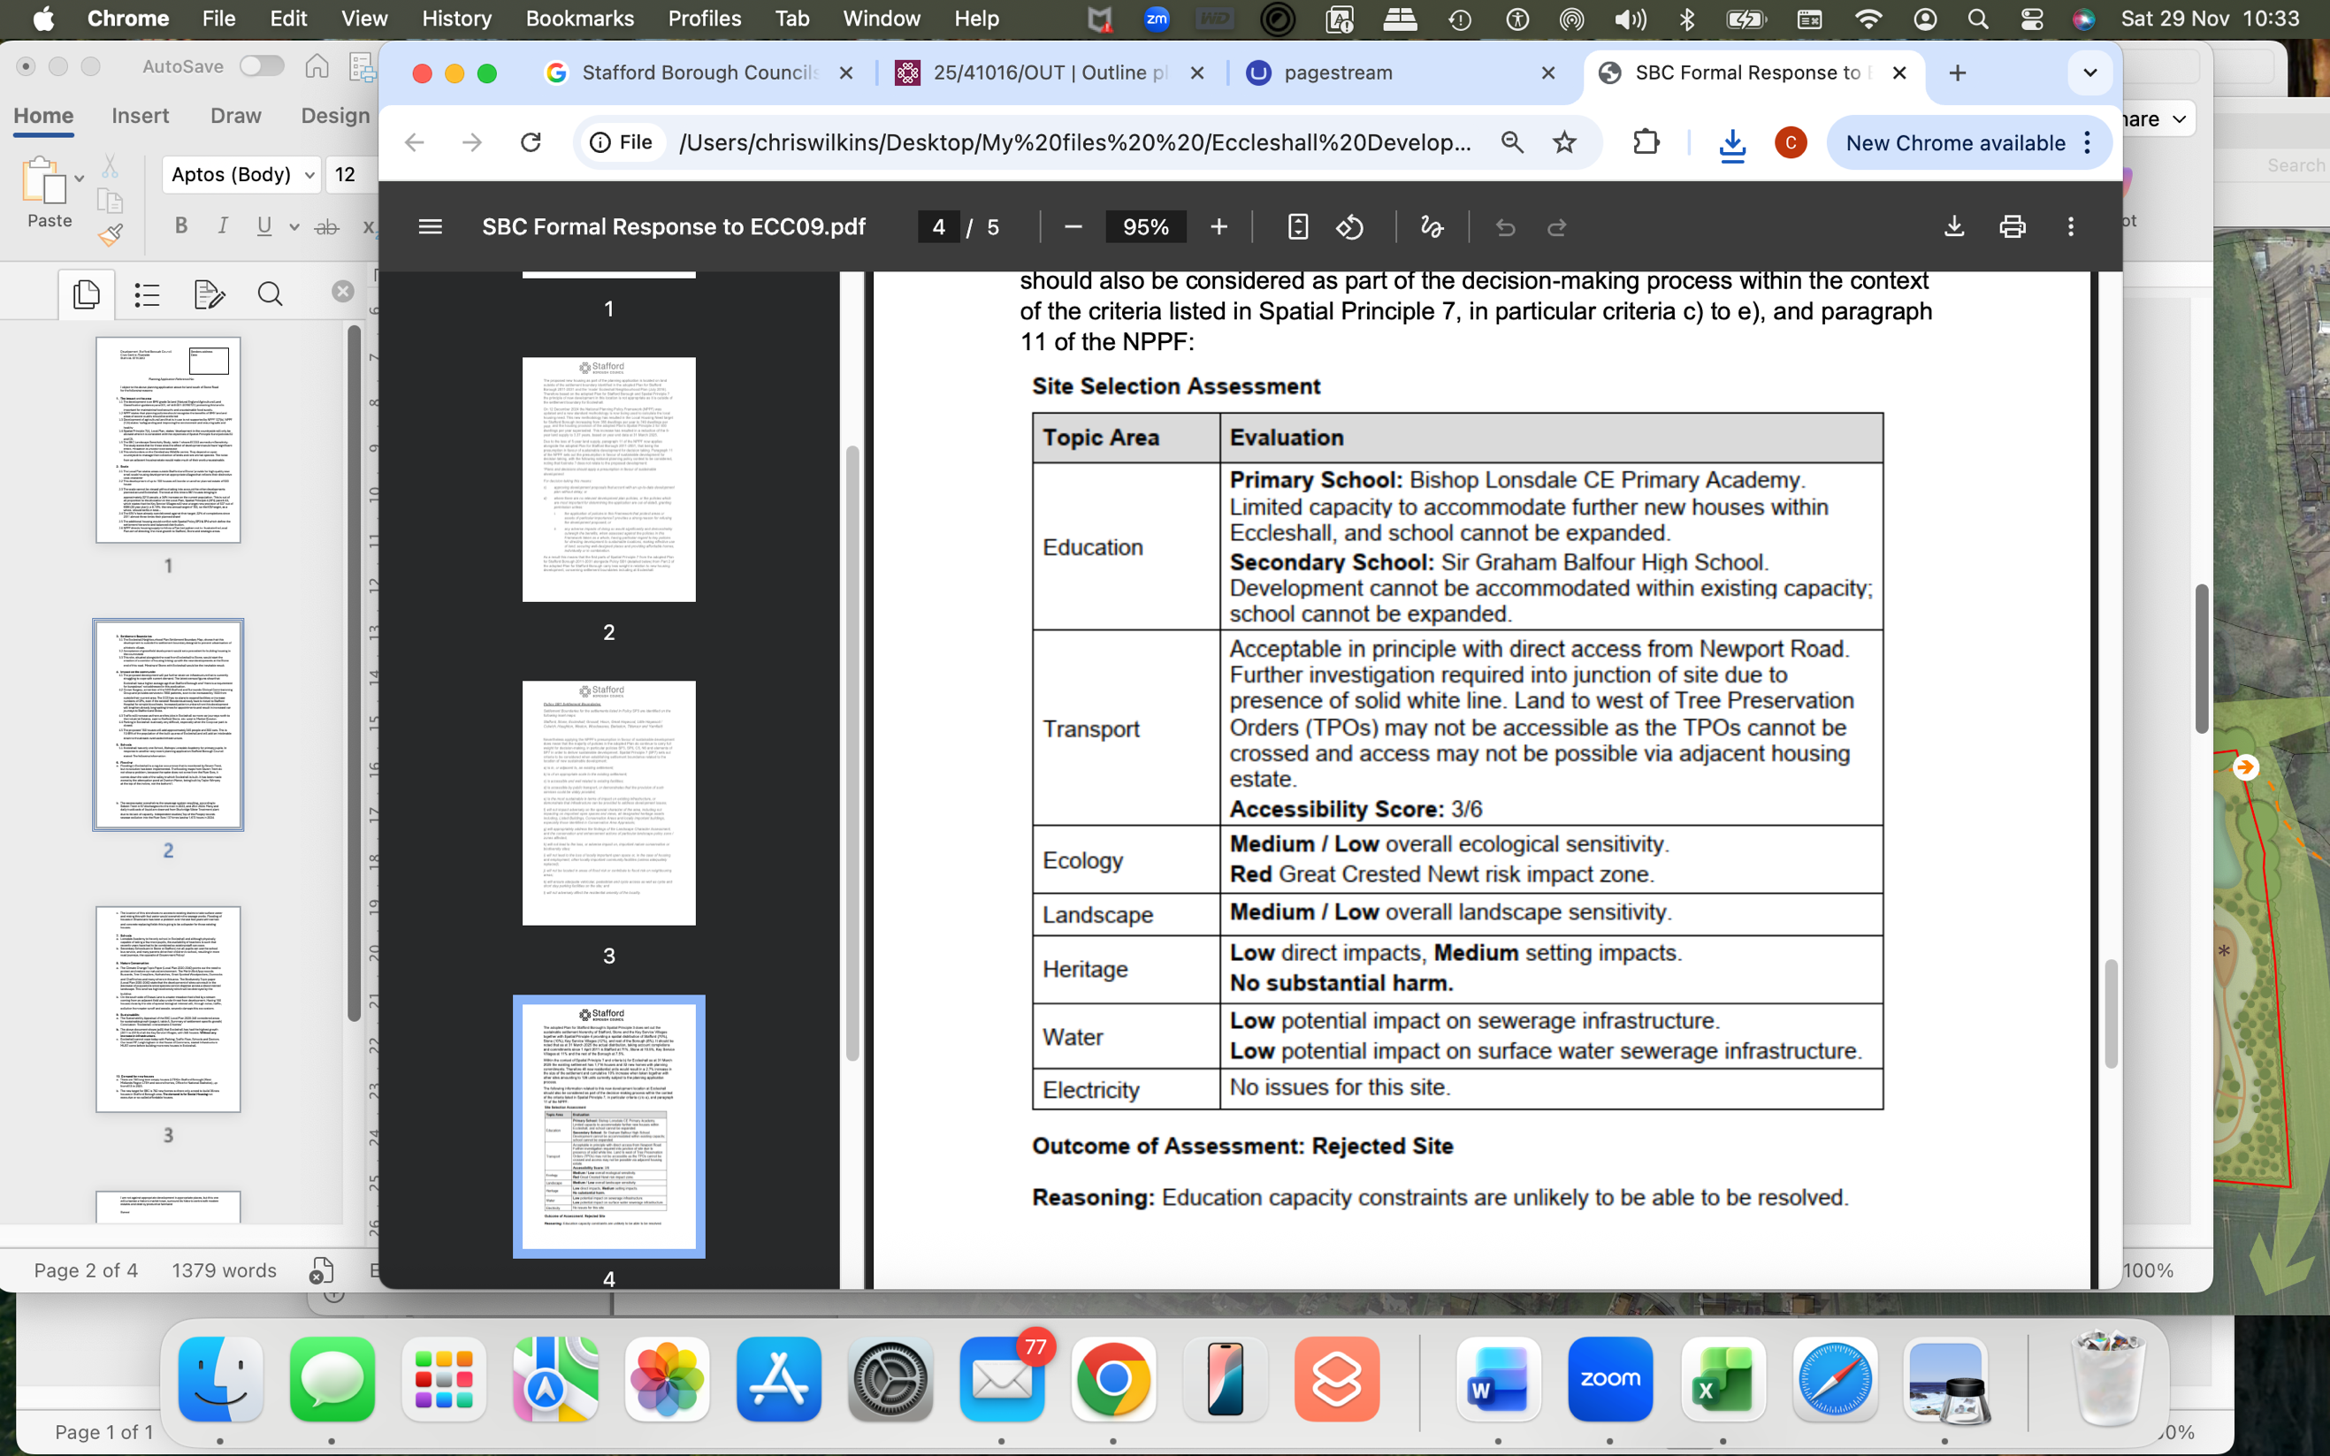

Conclusion
For the reasons outlined above —non-compliance with the Eccleshall Neighbourhood Plan, the SBC Local Plan, and relevant sections of the NPPF, as well as the demonstrable harm to the Eccleshall Conservation Area, inadequate infrastructure— I respectfully request that planning permission for the site above be refused.
Please confirm receipt of this objection.

Name:

