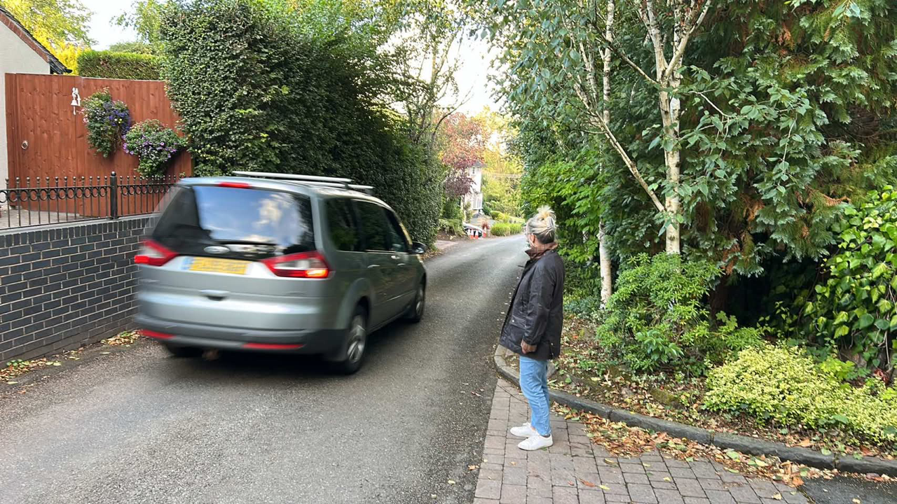
Kerry Lane
Don’t forget the 1.5m mandatory distance from pedestrians. I’ve been clipped twice this year (wing mirrors contacting my hand) because I didn’t give up my 1.5m.
IMPACT ON LISTED BUILDINGS and CONSERVATION AREAS - developments that could
aﬀect the character or setting of listed buildings or conservation areas are material
considerations
The development encompasses, in part, the conservation area of Eccleshall. In the Planning Act
1990, Section 69 (1) of the Act it imposes a duty on the local planning authority to identify areas of special architectural or historic interest and to designate those places as conservation areas.
Designation helps to ensure that an area identified is protected appropriately. Eccleshall
Conservation Area Appraisal 2014 (Staﬀord Borough Council) was undertaken in order to define the special character and appearance of Eccleshall and to identify any threats or future threats to its character and integrity. The appraisal discusses the fact that the shoe making cottage industry and associated trades developed around Kerry Lane. It also mentions that Kerry Lane possesses the character of a village, with smaller scale buildings. There is a certain threat to Kerry Lane retaining “it’s special character and integrity” with the certainty of increased traﬃc using this “narrow lane” as referenced in the appraisal. A modern housing estate will clearly detract from this nationally important amenity.
LANDSCAPE SENSITIVITY STUDY
Only 7 out of 140 have been assessed as sites of High sensitivity. In 2021 SBC commissioned AOC Archeology Group to undertake an Historic Environment Site Assessment (HESA) to form a key piece of the evidence base used to ensure that the impact on the historic environment has been properly considered in the site selection process.
It states that for those recorded as HIGH - “significant eﬀects predicted. Mitigation unlikely to be possible”.
The NPPF (2019). Chapter 16 is concerned with “conserving and enhancing the historic
environment”. It identifies heritage assets as an irreplaceable resource and notes that they
should be conserved in a manner appropriate to their significance.
The boundary of Eccleshall Conservation Area extends across the northern half of the site, whilst a range of listed buildings, including Grade 1 listed Holy Trinity Church, lie within 105m of the site boundary. There is particular mention of the Grade ll listed Thatched Cottage which stands 34m north of the southwestern site boundary and states that care would need to be taken to protect its setting. The Thatched Cottage is

